**Command lines(linux ubuntu)**

1. **What is a command line :**
2. **Most common commands :**

* **Ls :** show the content of a directory (files and other directories)

**Examples :**

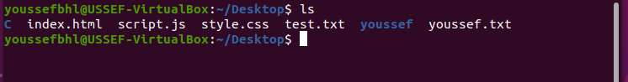

**Image1 : ls** show the content of the **Desktop** directory that we are already in



**Image2 : ls** show the content of **youssef** directory while we are in **Desktop** directory

**Ls most common arguments :**

* + **–a :** shows all files and directories including the hidden ones



**Image3 : ls –a** all the files in **Desktop** including **.youssef** and **.tst.html**

* + **–l** : use a long listing format

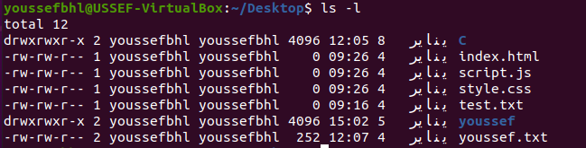

**Image4 : ls –l** list the files and directories but with **extra informations** like **size, author…**

* **Mkdir <name_of_directory> :** Create a new directory in the directory that you are curently in

**Example :**

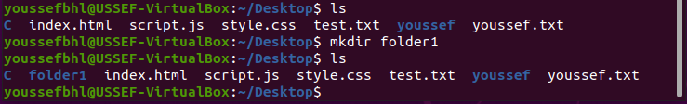

**Image5 :** here I created the **folder1** directory in the **Desktop** directory using **mkdir** command

* **Touch <name_of_file> :** create a file or multiple files in the directory that you are currently in

**Examples :**

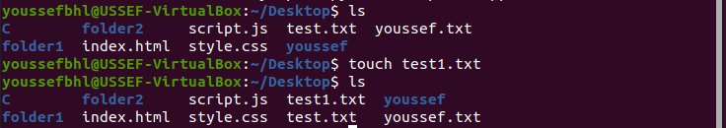

**Image6 :** here i created **test1.txt** in **Desktop** directory

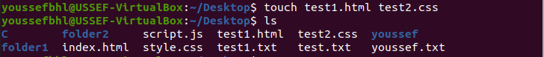

**Image7 :** here i created **two files** with the same touch command **test1 .html** and **test2.css**

* **rm/rmdir : rm** delete files while **rmdir** delete directories that are empty inside

**Examples :**

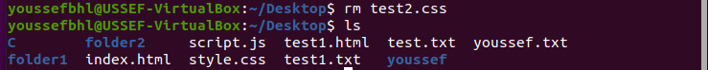

**Image8 :** here i deleted the **test2.css** file from the current directory

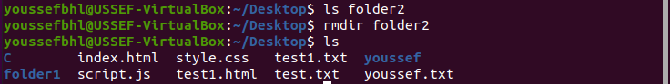

**Image9 :** here i checked if **folder2** is empty then i deleted it

* + **rm –r :** remove the content of a directory then remove the directory

**Example :**

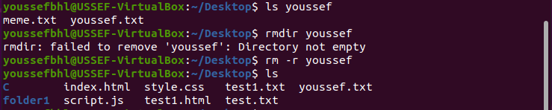

**Image10 :** here we tried to delete **youssef** using **rmdir** but the process **failed** because **youssef** was **not empty** thats why we should use **rm –r** to delete the content of **youssef** then delete **youssef**

* **cd <name_of_directory> :** make you enter a specific directory

**Example :**

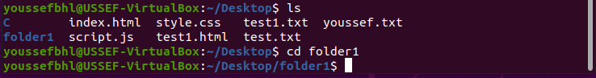

**Image11 :** here i entered the **folder1** directory

* + **cd and cd ~ :** enter the **home** directory

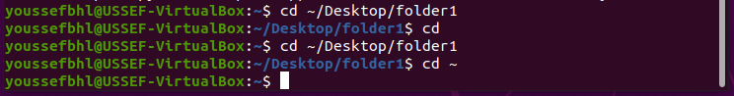

* + **cd / :** enter the root directory

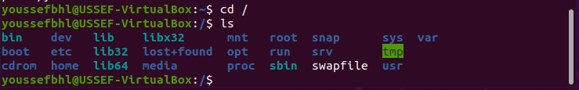

* + **cd - :** enter the last directory you were in

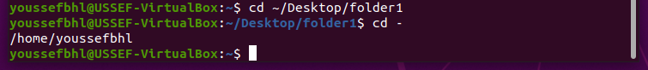

* + **cd .. :** go back one directory



* + **cp :** copy and paste a file or directory

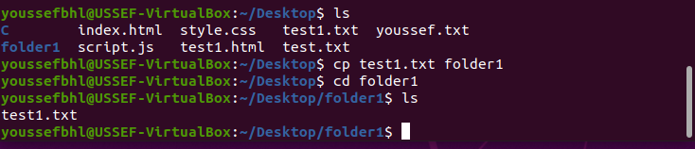

here i copied **test1.txt** and paste it in **folder1** directory

* + **mv :** we use it to **move a file or directory** to another and we can aslo **rename it** while moving it

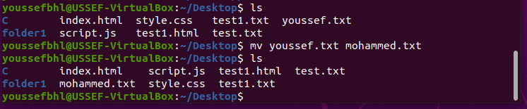

Here i moved **youssef.txt** to the same directory but i changed the name of it to **mohammed.txt**

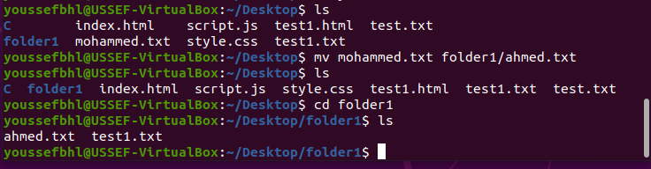

Here i moved **mohammed.txt** to **folder1** directory while changing the name to **ahmed.txt**

* + **ln :**create a symbolic link or a shortcut(raccourci) of a file from a directory to another one

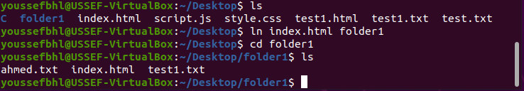

**NOTE :** if i changed the content of **index.html** in **folder1** the content of **index.html** in **Desktop** will also change.

* + **Cat / less / more :** show the content of a file in the terminal

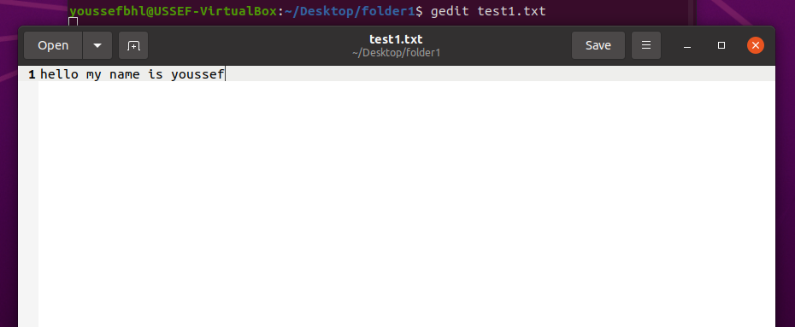

Here i opened test1.txt in the default text editor with gedit command

**Note :** we can also use the command code to open the file in vscode but we need first to install VsCode.